James Siddons
Sonata Hymnica No. 2

For Solo Piano
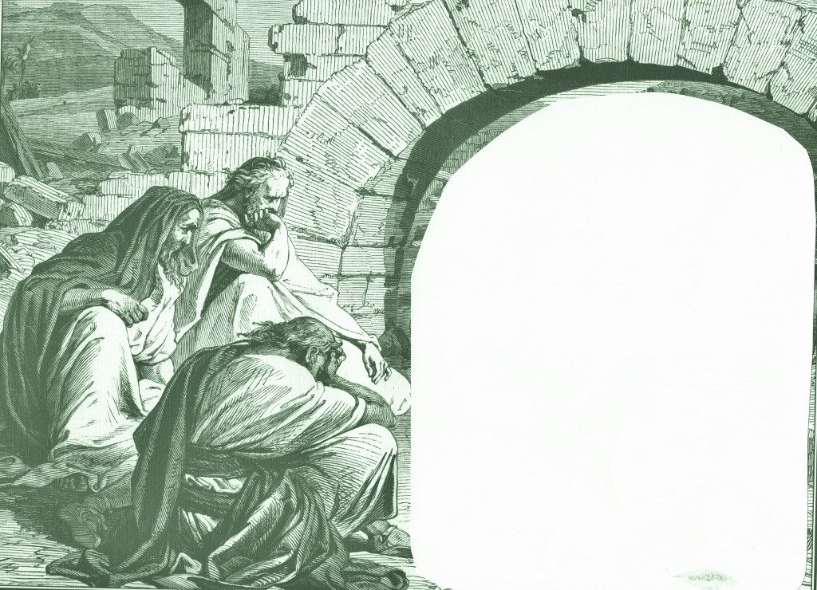

I. Farther Along (1911)

II. Ivory Palaces (1915)

III. Epilogue:
Lord, I’m Coming Home (1892)

Copyright 2018 James Siddons
www.JamesSiddons.com / ASCAP

